Semantics in ORD

The new features in OpenRoads Designer to add meaning to the Corridor Modeler

Ron Breukelaar

03/15/2022



## Why Add Semantics

The Corridor Modeler inside OpenRoads Designer (ORD) is a powerful tool to produce complicated linear 3D models. It is especially well suited to create models of roadways, embankments, walls, drainage features, etc., but it can be used to create a large variety of components and models. In a way the true power of the Corridor Modeler lies in its flexibility, but this also poses a problem.

In the world of BIM and domain specific exchange formats like IFC, there is a need for a more defined and aligned 3D model. One in which each object has a classification and a logical spatial structure that can be exchanged and understood by other third-party applications. In order to fulfill this need ORD version 10.10 has a new concept called “Semantics”. Its features are in tech preview right now and might change in the future, but this document describes how you can use these features and how they affect your upload to the iTwin and your export to IFC.

## Defining Semantic Rules

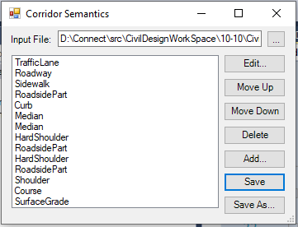In ORD 10.10 there is a new dialog called “Corridor Semantics”. There is no Ribbon button for this feature yet, so you’ll need to run the key-in “CORRIDOR SEMANTICS EDIT”. You will see a dialog pop-up similar to the picture on the right.

It shows you the list of rules that determine what part of a Corridor gets which list of Semantics. The rules in this list get applied in order from top to bottom, so the order of this list is important. Note that there can be multiple rules attached to a single Semantic name.

ORD 10.10 ships with a standard set of these rules, they generally work well on the default Corridor templates that are also shipped with the application, but this does not mean it works for your custom set of templates of course.

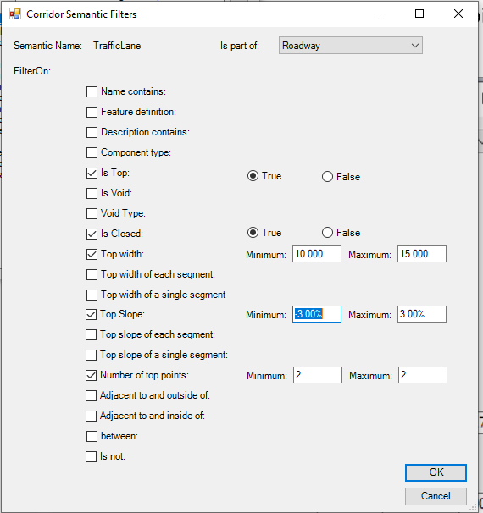If you edit one of these rules you’ll see a dialog something like the picture on the left.

The rule can filter on a whole range of triggers. When all the triggers that are switched on for a rule are met, then the Semantic is added to the component. Note that there is also a parent – child definition at the top in the “Is part of”. This setting allows you to create a whole tree of Semantics, or in IFC terms: “a Spatial Containment”

Currently the following Semantics are supported:

Roadway Plateau, Traffic Lane, Roadway, Sidewalk, Soft Shoulder, Hard Shoulder, Shoulder, Median, Roadside, Roadside Part, Curb, Course, Surface Grade, Pavement.

The figure above shows the spatial breakdown of a typical roadway cross section using the Semantic classifications used by the Rule Engine.

In addition to the classifications above, ORD also has a few additional categories of objects:

* Pavement – a pavement is considered to a contiguous set of closed components that represent any relatively flat hard surface and all the components underneath it. In the above diagram the sidewalk would be a pavement object. The roadway and all the components underneath would be another pavement, and the shoulder and all its sub-components would also be a pavement.
* Surface grade – any open mesh component that represents the top of the surface (e.g grass or dirt areas)
* Course – any relatively flat and shallow (high width/thickness) closed shape.

## Adding Semantics to Corridor

In order to add this Semantics to a Corridor Model you need to run another key-in command: CORRIDOR SEMANTICS ADD. This will prompt you to select the corridor you want to add semantics to and then apply the current rules to generate semantics.

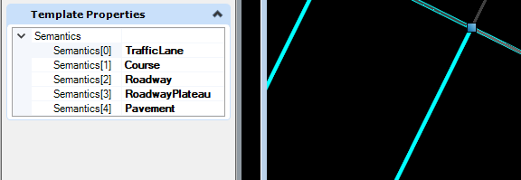

These semantics will show up as “Template Properties” on the mesh components of the corridor. Above you can see an example of these properties. You could edit these manually, but this is not recommended. If there is something wrong with your semantics, you should edit your semantics rules instead and reapply them to this corridor.

## Semantics inside iTwin

After you publish your project to an iTwin (for instance using the iTwin Synchronizer) you will see that the Classifications and the Spatial Containment make it into the model. Below is an example of what a Spatial Containment might look like:

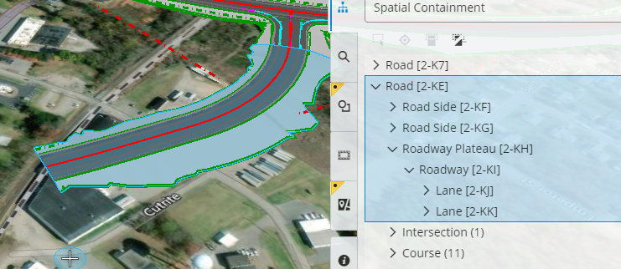

## Mapping from Semantics to IFC

IFC is a file standard by buildingSmart that has recently made some efforts to support more Civil Engineering workflows in a new version called IFC4x3. As part of that effort, they have extended their standard to include (among other things) Road classifications (classes and predefined types) and spatial containment definitions. As of the time of this document the standard is not finished yet and is still undergoing minor revisions. On top of that, the standard does not define a strict definition of how to use the different classes and spatial relationships, or which of them are mandatory in what workflow. This makes what follows at best temporary.

When you try to map the IFC class and type definitions to a typical cross section you end up with something like this:

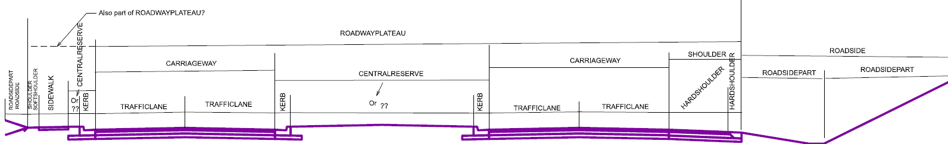

Note how it is unclear whether the Sidewalk is included in the Roadway Plateau or not, or what to call the area between the “Kerbs” in a Central Reserve. Then the (additional) definitions of Course and Pavement mix and overlap these spatial definitions, while the Kerb is not a spatial definition at all, but rather a “Built Element”.

Let’s just say that we had to make some hard decisions and interpretations that might not line up with the way others have interpreted the IFC standard (which would be unfortunate), but we hope this will start a dialog that will improve this understanding in the future.

Below is our interpretation of the spatial containment and built elements with their predefined types and relationships. ORD 10.10 has a tech preview option to try and generate this structure from the semantics, but only for the IFC4x3 RC4 version in the Corridor Exporter. This does not work for the IFC4 or earlier versions of course.

* IfcRoad, RelAggregates:
  + IfcFacilityPart, IfcRoadPartTypeEnum.ROADWAYPLATEAU, RelAggregates:
    - IfcFacilityPart, IfcRoadPartTypeEnum.SHOULDER, RelAggregates:
      * IfcFacilityPart, IfcRoadPartTypeEnum.HARDSHOULDER, RelContainedInSpatialStructure:
        + IfcPavement, RelAggregates:

IfcCourse, IfcCourseTypeEnum.PAVEMENT

* + - * IfcFacilityPart, IfcRoadPartTypeEnum.SOFTSHOULDER, RelContainedInSpatialStructure:
        + IfcEarthworkFill, IfcEarthworksFillTypeEnum.EMBANKMENT
    - IfcFacilityPart, IfcRoadPartTypeEnum.CARRIAGEWAY, RelAggregates:
      * IfcFacilityPart, IfcRoadPartTypeEnum.TRAFFICLANE, RelContainedInSpatialStructure:
        + IfcPavement, RelAggregates:

IfcCourse, IfcCourseTypeEnum.PAVEMENT

* + - IfcFacilityPart, IfcRoadPartTypeEnum.CENTRALRESERVE, RelContainedInSpatialStructure:
      * IfcKerb
      * IfcEarthworkFill, IfcEarthworksFillTypeEnum.EMBANKMENT
    - IfcFacilityPart, IfcRoadPartTypeEnum.SIDEWALK, RelContainedInSpatialStructure:
      * + IfcPavement, RelAggregates:

IfcCourse, IfcCourseTypeEnum.PAVEMENT

* + IfcFacilityPart, IfcRoadPartTypeEnum.ROADSIDE, RelAggregates:
    - IfcFacilityPart, IfcRoadPartTypeEnum.ROADSIDEPART, RelContainedInSpatialStructure:
      * IfcEarthworkFill, IfcEarthworksFillTypeEnum.EMBANKMENT
      * IfcCourse, IfcCourseTypeEnum.PAVEMENT

Note that the above structure uses as much of the Infra classes as possible and adds predefined types where this made sense. In some cases, levels in the hierarchy are optional, like for instance the TRAFFICLANE can be omitted. In which case the built elements are linked to the parent, the CARRIAGEWAY in the example. Also the use of the PAVEMENT type was a topic of debate since it could in theory span multiple traffic lanes and hard shoulders, but that would break the hierarchical structure.

The Semantics coming out of ORD 10.10 are not exact matches to the IFC classes. Below is a mapping from ORD to IFC classifications:

|  |  |  |
| --- | --- | --- |
| ORD | IFC Class | IFC Type |
| Road | IfcRoad |  |
| RoadwayPlateau | IfcFacility | IfcRoadPartTypeEnum.ROADWAYPLATEAU |
| RoadSide | IfcFacility | IfcRoadPartTypeEnum.ROADSIDE |
| Shoulder | IfcFacility | IfcRoadPartTypeEnum.SHOULDER |
| Roadway | IfcFacility | IfcRoadPartTypeEnum.CARRIAGEWAY |
| Median | IfcFacility | IfcRoadPartTypeEnum.CENTRALRESERVE |
| Sidewalk | IfcFacility | IfcRoadPartTypeEnum.SIDEWALK |
| RoadSidePart | IfcFacility | IfcRoadPartTypeEnum.ROADSIDEPART |
| TrafficLane | IfcFacility | IfcRoadPartTypeEnum.TRAFFICLANE |
| HardShoulder | IfcFacility | IfcRoadPartTypeEnum.HARDSHOULDER |
| SoftShoulder | IfcFacility | IfcRoadPartTypeEnum.SOFTSHOULDER |
| SurfaceGrade | IfcEarthworkFill | IfcEarthworksFillTypeEnum.EMBANKMENT |
| Pavement | IfcPavement |  |
| Course | IfcCourse | IfcCourseTypeEnum.PAVEMENT |
| Curb | IfcKerb |  |

## Future Work

This work is all in Tech Preview and might change in the future. This document is likely to be outdated soon, if not obsolete.

We would love feedback on the features, the structures and mappings outlined in this document to continue this effort in the future. For feedback or any further questions please reach out to [ron.breukelaar@bentley.com](mailto:ron.breukelaar@bentley.com) (Ron Breukelaar).